Tank Game Introduction

It is a classic tank game containing single player mode, dual player mode and map preview and editing as the below picture shows. There are 14 maps right now which means 15 levels.

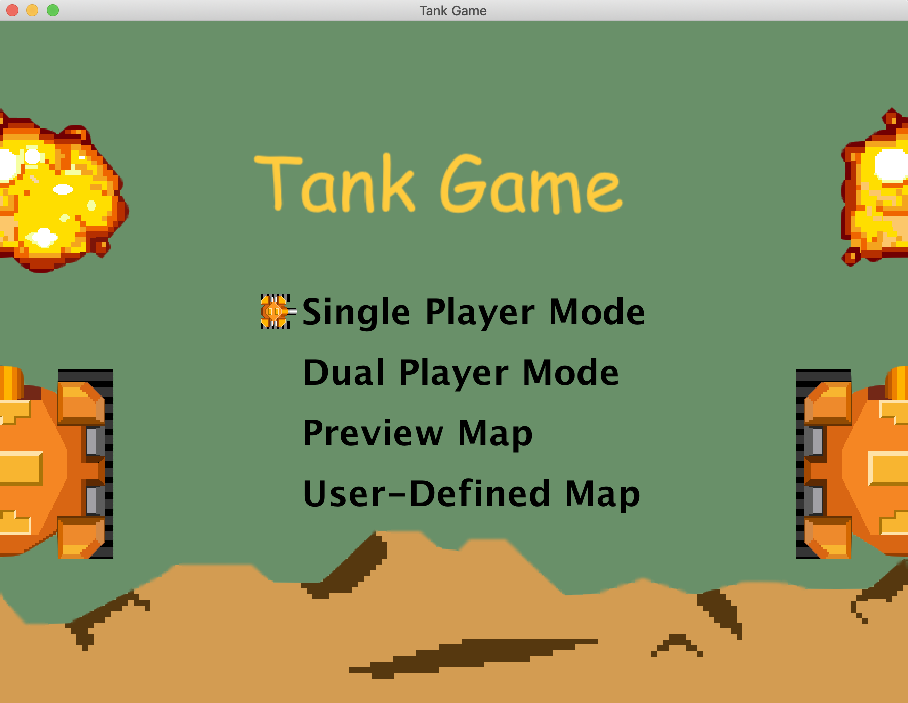

Use direction key to control the small orange tank to move, and press enter key to make a choice.

* Single Player Mode

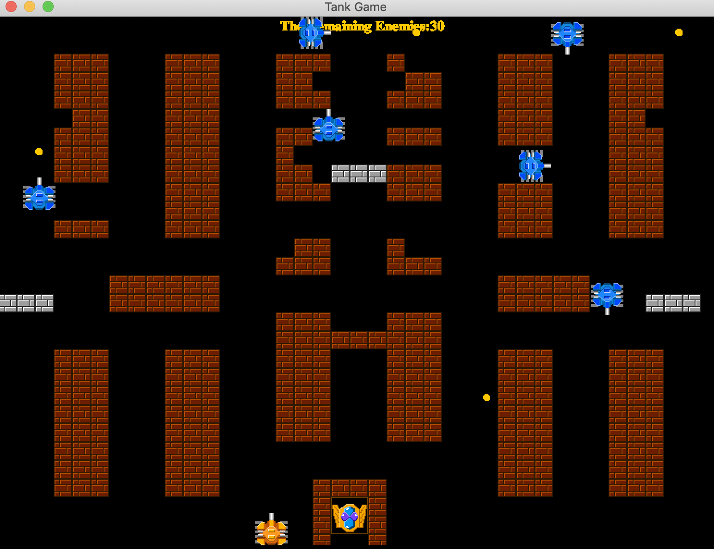

Player 1 control key: w: up, d: right, s: down, a: left, y: attack

* Dual Player Mode

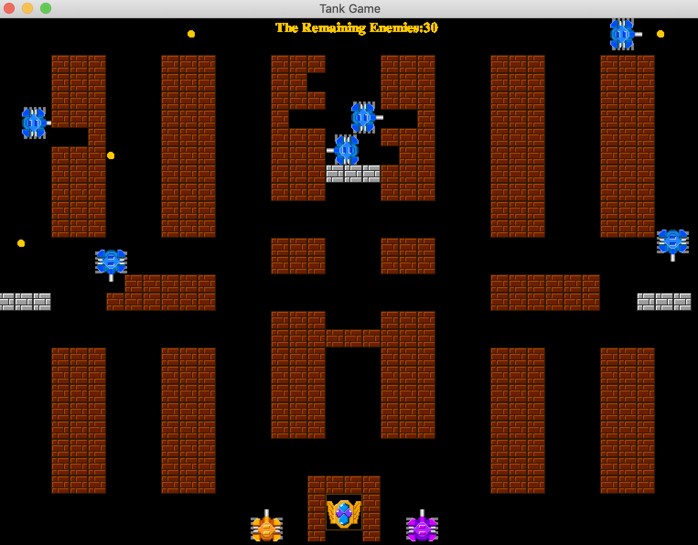

Player 1 control key: w: up, d: right, s: down, a: left, y: attack

Player 2 control key: direction key, num1: attack

* Preview Map

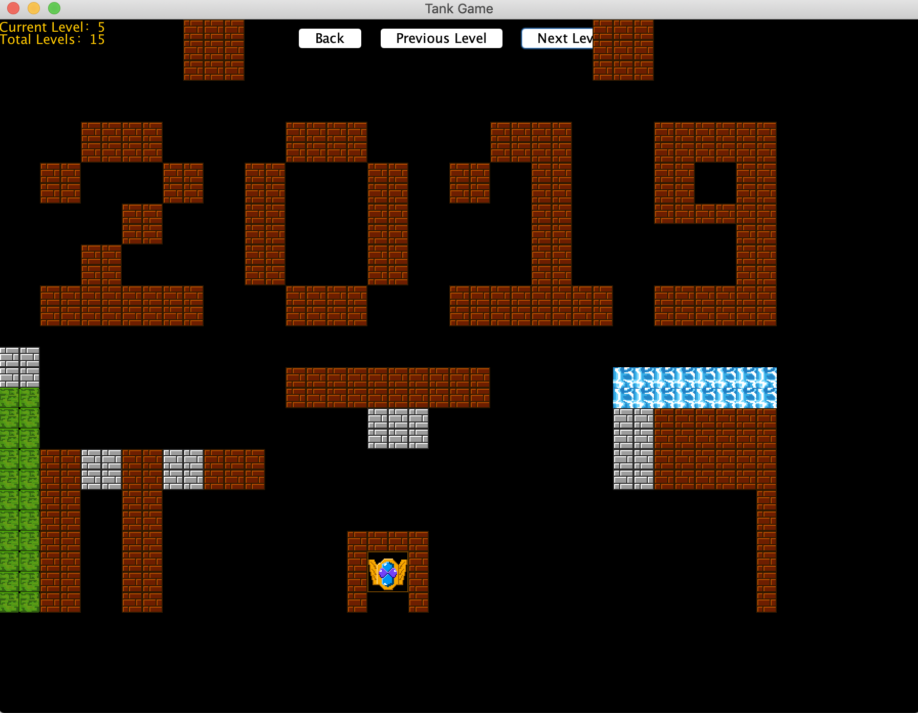

PreviousLevel: go to previous level

NextLevel: go to next level

Back: Back to the login panel

* User-Defined Map

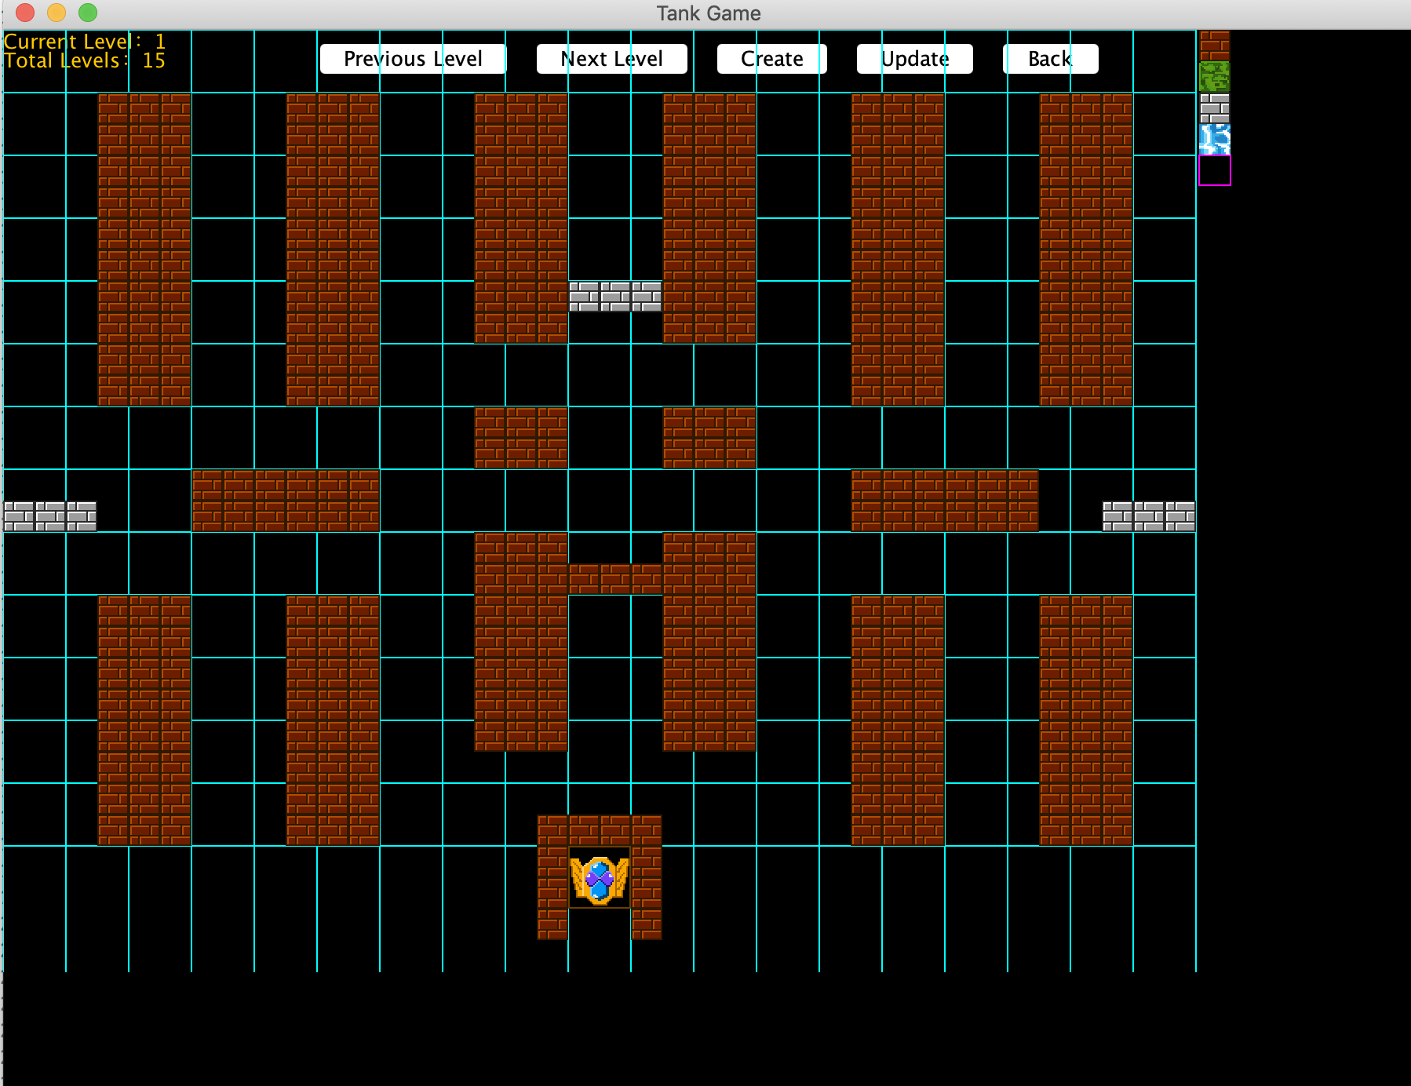

Create: create a new map and store it

Update: Modify a old map and store it

Back: Back to the login panel

Click the four kinds of walls in the right, and place in the map.

Click the eraser in the right, and click the walls in the map, erase the walls.